HAMAHIGA ISLAND prepared by S. A. Mick McClary – ClickOkinawa.com – Sep 9, 2022
It is often said that the impediment to advancing research on the history of Okinawa is the lack of historical materials from the Ryūkyū Kingdom era. The same is certainly true for Hamahiga island. There are very few historical materials that consider the history of Hamahiga island during the Ryūkyū Kingdom era, [especially English-language publications] and unfortunately very few remain. The following is the result of summarizing from the limited data. Therefore, this paper only outlines one aspect of Hamahiga island's history. My thanks to Kazutshi Nakandakari for directing me to the following piece, entitled Some Notes on the History of Hamahiga Island, apparently written by Shiichi Toma and is in the Okinawa Prefectural Museum.
The following is derived from the use of Internet-based auto-translation technology. It is almost verbatim. I have restructured some of the text in an attempt to make it more easily comprehensible. My own commentary is [in brackets]. I’m uncertain regarding the date of publication of this paper but judging from the text and references I can deduce that it was after 1986 and before 1997.
For words or, especially, place names that I have not been able to confirm for accuracy of the auto-translation, I have placed an asterisk (*) after those words. If you are reading this and you do find an inaccuracy, please let me know. You may contact me by email: Mick-Admin@ClickOkinawa.com
Hamahiga Island belongs to Katsuren Town in the central part of the main island of Okinawa and is a small island floating in the sea about 3.55 kilometers east of Yakena port, a village on the east side of the main island. The village on the east side is Katsuren Aza Higa [hereinafter referred to as Higa Village]. Currently, transportation to the island takes about 15 minutes by rapid boat to Higa, and about 40 minutes by two to three ferries to Higa. [This reference was obviously before the completion of the Hamahiga Ohashi (Bridge) in February 1997. I include it here for its historical charm.]
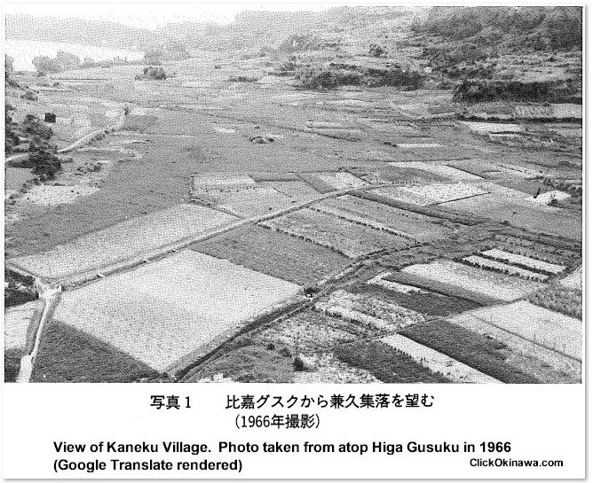
It consists of rocky soil and alluvial soil sphere limestone. The terrain rises to the west and is almost flat as a whole, measuring only 78.7 meters at its highest point. Higa Village is located on the coastal sand dunes, and the coastline stretches like a beautiful white sandy beach. The eroded topography in the Aza Higa direction continues with 15 meter-high cliffs and at the foot of the sea cliffs where coral reefs in sandy beaches were scarcely developed. Alluvial land was opened and used as land for settlement. Underground gushing [spring] can also be seen from the upper edge of the shear Shimajiri Formation that appears on the sea cliff.
Overview of Hamahiga Island - The island has many archaeological sites. The ruins of Okinawa date from the Shell Mound Period to the Gusuku Era and are said to have been the stage of human activity from 3,000 years ago to the present day. The limestone Cave of Doline [sink hole open space], about 300 meters north of Higa Elementary School, is an utaki [sacred place] in the middle of the village, the place of faith, and is about 3,000 years old.
For some reason the people who first settled on Hamahiga island in the early period of the Kaizuka Period [Kaizuka Period in Okinawa-related discussions coincides with Japan’s Jomon Period], when farming had not yet been practiced. They preferred narrow limestone areas like this utaki and made it their stage of life.
They formed a group of blood relatives consisting of several people and lived in a pit shaped cave called Doline, where they hunted and fished. Some 2,000 years ago, the Kaizuka people abandoned the narrow limestone land in which they had lived and moved into the open side of the limestone hill plateau to the west of Koneku* Village. For them this hilly plateau was a completely different place from where they had been before, and a place where they could secure a new life. Although this site has not been surveyed and is currently reported as a scattered area, judging from the site conditions it appears to be the site of a primitive settlement of the people, just like the Shinugudo* site on Miyagi Island and the Nakabaru site on Ikei Island. There is a strong possibility that this is a settlement site. (see my YT video of Nakabaru - https://youtu.be/v_QqAlSJMxE)
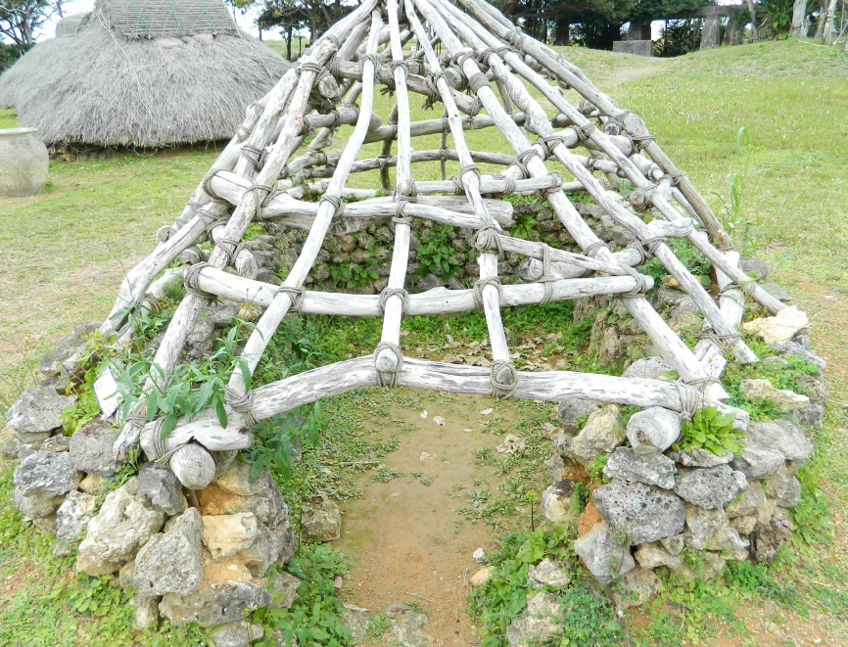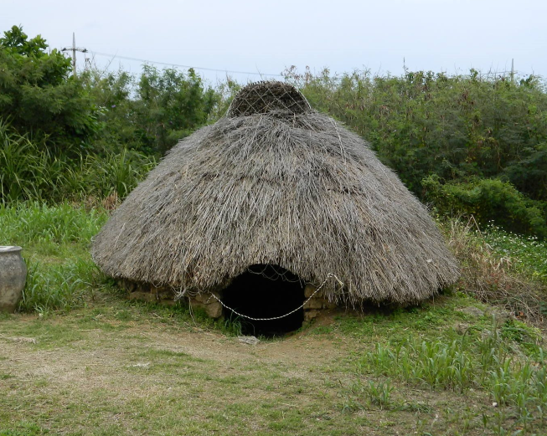
Dwellings found in Nakabaru Village on Ikei Island (photos by S.A. McClary March 16, 2016)
During this period, Okinawa’s shell mound people began to form relatively large settlements here and there. The islands of Ikei, Miyagi, Henza, and Hamahiga, which are connected to the Katsuren Peninsula, are all small islands but the ruins of this period are scattered like gems. There are the Nakabaru ruins on Ikei Island, the Shinugudo Banto (cliff) – [Shigumu?] ruins and Takamine ruins on Miyagi Island, the Higashi-Hantahara ruins on Henza island, and the Koneku* West Hill Relics Scattering Site on Hamahiga Island.
Thousands of years ago, the Hamahiga people moved their livelihoods to the sand dunes facing the lagoons of coral reefs. During this time, the population increased and the living area expanded. The Hamakai Midden, which stretches from the field in front of Maenoido* to the school grounds of Hama Junior High School, is well known among researchers as a relic from that time. Since the site overlaps with the current beach village, it has been destroyed year by year due to housing construction and road repairs. More than 10 years ago [unable to ascertain when that would have been], when digging the foundation to build a gymnasium, human bones were discovered causing a big fuss. At that time I was working in the Prefectural Cultural Affairs Division and several people including Masanori Kintake*, a senior expert at the museum, spent the night excavating this human bone.
About 800 years ago, local feudal lords called aji appeared and established gusuku in various parts of Okinawa and began to compete with each other for power. This era is called the Gusuku Era and it continued until about 400 years ago. The castles built around this time were Hama Gusuku and Higa Gusuku.
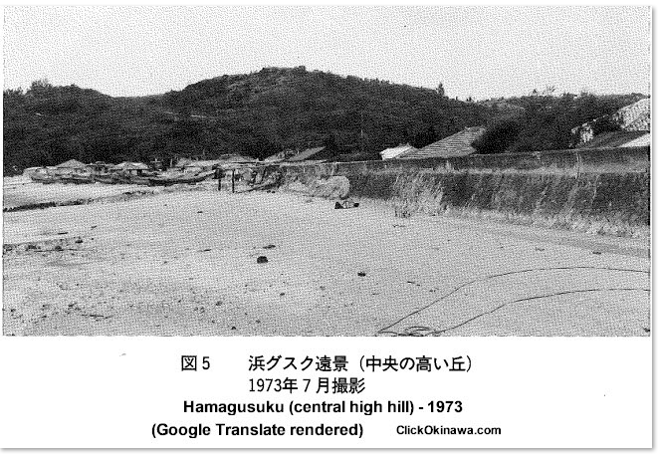
Out of the conflicts between the ajis, “aji among ajis” emerged. [Those would have been the yo-no-nushi.] They eventually came to be called “masters of the great world.” The Lords of the great world sought to amass wealth and strengthen their political power by carrying out intermediary trade with China and other countries, mainly in mainland Japan. A large amount of fragments of imported ceramics obtained through Nankai* trade have been excavated from the ruins of gusuku where they lived. The Katsuren gusuku which was built at a strategic point overlooking the entire Katsuren Peninsula, was the residence of the Lord of the world who ruled this area. It was a prosperous gusuku that could be compared to the ruins of Mitsuko Castle, many original-style blue and white flowers have been excavated showing the prosperity of the time.
In Omoro Soshi, Vol 16-5 No.1131 (Japanese Belief System), Amamichu, a goddess with great power, descended to Momonoyose Sasuka Osoi* – a building within the castle – and danced in groups. It seems this omoro teaches us the following two things about the history of Hamahiga Island:
First, the surrounding islands were already under the rule of Katsuren gusuku when this omoro was sung. It is likely that the two gusukus built on Hamahiga Island were under the control of the more powerful Katsuren aji, ruling the people of both Hama and Higa settlements, and managing their respective gusuku. Then, what kind of gusuku were the Hama gusuku and Higa gusuku? Hama gusuku is [located] at the top of the Ryukyu limestone plateau, about 60 meters above sea level, to the east southeast of Hama Village. It is located overlooking the village. There are natural cliffs around the gusuku, but only one direction is gentle and there is a tiger mouth attached to it.
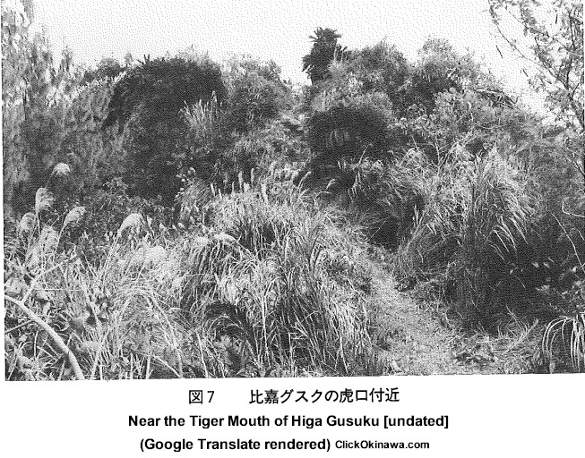
The inside of the castle gradually rises from the north to the south, and the relative height difference between the low and high places measures about 3 meters.
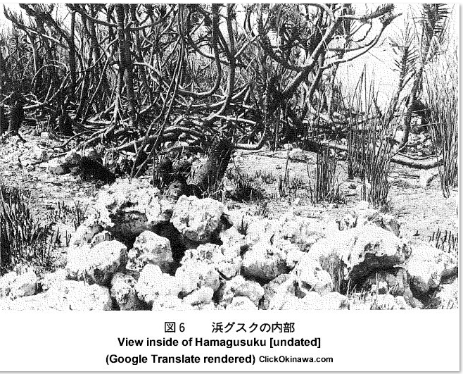
The south side is a continuous gusuku consisting of three flats. A stonewall with a nozura surface can be seen in part of the castle grounds, but most of it has collapsed and the appearance of the past has now stopped. [There are two techniques for building stone walls in Okinawan architecture called nozura-zumi and kiriishi-zumi. The nozura-zumi technique positions large stones of various sizes and shapes in a relatively haphazard orientation while exhibiting no concern for aesthetics thereby giving the wall a very disorganized appearance. Kiriishi-zumi construction utilizes hewn stone cut roughly into squares and rectangles making the wall much more visually appealing.] The view from gusuku is good and you can see the beach village below, Henza Island to the north, Katsuren Peninsula to the west, and Tsuken Island to the south.
Higa gusuku is located on a small hill made of Ryukyu limestone in the southwest of Higa Village. The top of the hill, which corresponds to the main enclosure, is surrounded by cliffs and is a natural fortress. To enter the gusuku, go a few 10s of meters along the road from the old Community Center of Higa Village to Hama Village. You will find a sloped path that turns to the left. As you climb up this path you can see a stepped flat land on both sides. The flatland once formed the citadel. If you keep going up with these enclosures on both sides, the path will turn left. If you go further about 10 meters you will reach a rocky mountain. The top of this rocky mountain should be called the main enclosure of Higa gusuku. Currently overgrown with Japanese pampas grass and miscellaneous trees, it is not possible to know the details of the internal structure from a superficial observation.
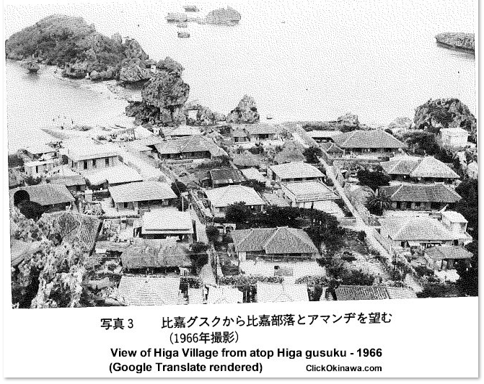
By the way, on both sides of the ruins from Ochigawa* to the gusuku, there are several terraced flat fields which are intentionally placed to protect Koguchi*. If you look at the territory of this Higa gusuku, you can clearly see that the uppermost flat field was the main enclosure and that the mouth was narrowed on purpose to prevent intrusion into this main enclosure, and that the mouth was devised to have steps.
Gusuku played a major role in unravelling the history of the time as to why a gusuku with so much territory was necessary for such a small island. It is not clear when or by whom Higa gusuku and Hama gusuku were built. It is probable that the two gusuku were established around the 14th or 15th century when various ajis established gusuku in their respective territories thus establishing their own domain. As if to prove this, fragments of imported ceramics produced in China around the 14th and 15th centuries and brought in by the ceramics trade have been unearthed in and around the gusukus. The Gusuku Period is a time division established by Okinawan archaeologists as the period following the latter half of the shell mound period and refers to the period from around the 12th century to around the 15th and 16th centuries. The time when gusuku, which are distributed in various parts of Okinawa, was built is exactly that time and in Japanese history, it corresponds to the period from the late Heian Period to the Kamakura/ Muromachi Period. In addition to the gusuku that serve as indicators, the ruins of this period include the Hama gusuku Southern Dispersal Site, the Meehanchargama* Cave Site, the Hama Elementary School East Artifacts Disposal Site, the Hamagawa Cave Site, and the Kuba Island Artifacts Dispersal Site. No excavations have been carried out on either of them so the details are still unknown.
The second is about the name of Hamahiga Island. This description of “ba” in Omoro Soshi is probably the first manifestation of how Hamahigajima is called. Later, Hamahiga Island was mentioned as “Hama” in Chuzan Denshinroku [a book by a botanist and physician of the Edo government] and Ryukyu Kokushiryaku* and in Goville’s Ryukyu Memorandum.
The emergence of agriculture led to the development of human habitation which had previously moved from one place to another to obtain food, toward a more sedentary lifestyle, and eventually led to the emergence of Buraku. [Buraku people or Burakumin (min refers to people) are the largest discriminated-against population in Japan. They are not a racial or a national minority, but a caste-like minority among the ethnic Japanese. They are generally recognized as descendants of outcaste populations, such as executioners, undertakers, slaughterhouse workers, butchers, or tanners in the feudal days.]
Hamahiga Island, which is surrounded by the sea on all sides, was highly dependent upon the sea so it is thought that there was no need to change the place of living to obtain food. Therefore, the occurrence of unevenness [social disparities?] is also considered to belong to a relatively early stage. At first, Hama Village existed as a scattered village in the vicinity of Hama gusuku, but as the population increased they eventually settled on the south side with the gusuku at their back. They then moved south from the Oden* near Agariga* and the east Tsurukawa* area. It seems to be a gradual expansion and development. In the case of Higa Village, small settlements would have been formed around the natural water of Wienugaa*.
During the Gusuku Period as mentioned at the beginning, Hamahiga Island was under the administration of Katsuren’s Aji Amawari. According to local lore, he exercised benevolence and earned the trust of his people but he was destroyed by the army of Shō Taikyu for betraying the royal government of Shuri sometime in 1458. [I have discussed that topic in my book, Timeline: OKINAWA that reads, in part, “Gosamaru had been a faithful servant and defender of the Ryukyu king, Shō Taikyu. He built Nakagusuku Castle so that he could be in a better position to watch out for threats against his king. Amawari, Lord of Katsuren Castle had in mind a plot to do away with Shō Taikyu but Gosamaru was running interference from his post at Nakagusuku. Amawari pulled a fast one on Gosamaru by reporting to the king that Gosamaru was plotting his, the king’s, demise. Word got back to Gosamaru that the king had been informed of Amawari’s ruse. Gosamaru, devastated by even a thought that he would be so disloyal elected to end his own life. He and his army of warriors took their lives en masse. Prior to killing himself however and knowing that it would be Amawari’s intent to deliver his head to the king, Gosamaru wrote a note to the king, explaining that he had been lied about by Amawari. The note further asserted his faithfulness. He wadded up the note, stuck it in his mouth then proceeded to kill himself. The king found the paper, Amawari’s trickery was exposed, and justice prevailed. Katsuren was attacked by the Shuri-based Ryukyuan army led by general Uni-ufugusuku, Amawari was captured and executed.]
In 1609, Satsuma dispatched more than 3,000 soldiers to Ryukyu and invaded Shuri castle. After that, Ryukyu came to be under the control of Satsuma, and the rule of the Ryukyu Kingdom was strengthened by enforcing the laws called “15 rules” and giving jurisdiction over tax receipts and payments imposed on residents of Hamahiga Island. Those tax issues were previously under the jurisdiction of the governor of the government of Shuri. The burden of the peasants at that time was heavy, and the burden of payment to the royal government, tribute to Satsuma, payment of the landlord’s salary, etc. was imposed on a village by village basis.
[The “15 rules’ mentioned above refers to the Law of Fifteen Injunctions. Satsuma presented a 15-point edict to the Ryukyu King, Shō Nei, spelling out what conduct was expected from those in the Okinawa islands:
The LAW of FIFTEEN INJUNCTIONS
Art. 1.: No goods other than those authorized by Satsuma shall be taken to China.
Art. 2.: No emoluments shall be given to any member of any family, however illustrious a pedigree he may have, unless he is currently in public service.
Art. 3.: No emoluments shall be given to women.
Art. 4.: No private servitude shall be allowed.
Art. 5.: Shrines and temples shall not be established and maintained in excessive numbers.
Art. 6.: No merchants shall be allowed to engage in trade to or from Ryukyu without the officially sealed permit of Satsuma.
Art. 7.: No inhabitant of Ryukyu shall be bought or sold and taken to Japan.
Art. 8.: All annual taxes and other public imposts of a similar kind shall be levied in accordance with the rules and regulations stipulated by the Resident Commissioner of Satsuma (in Naha).
Art. 9.: The conduct of public affairs shall not be entrusted to any person other than the Three Councilors (sanshikan).
Art. 10.: No persons shall be compelled to purchase or sell against his will.
Art. 11.: Fights and quarrels are prohibited.
Art. 12.: Reports shall be made to the authorities in Kagoshima, in case of any official making any unreasonable and unjust claim upon merchants and farmers or others exceeding the amount of taxes and labor duties properly to be levied according to prescribed law.
Art. 13.: No merchant ship shall be allowed to go from Ryukyu to any foreign country.
Art. 14.: No measure for grains other than the standard measure known as Kyōban shall be used.
Art. 15.: Gambling and all other vicious habits of a like nature are prohibited.]
Regional control of the Ryukyu Kingdom was carried out through the magirimura system. Magiri was roughly equivalent to the current municipality, and the towns within the magiri were the mura. According to records, Hamahiga Island belonged to the Katsuren section and until 1675, there was only one village - Hamamura, but in 1676, when the Yonashiro section was newly established, Higa village was established.
Rice production was greater on Hamahiga Island than neighboring Henza, Miyagi or Ikei Islands which were predominantly flat soil lands, rather than paddy fields. Hamahiga Island was overwhelmingly paddy fields.
Land consolidation was completed in 1903 (Meiji 36 ), and with the enactment of the land tax ordinance, the conventional land-sharing system was changed to a private ownership system. Before the land consolidation, Okinawa's land system was based on land allocation, so most of the cultivated land was shared by villages. However, after the land consolidation, private ownership of land was established and taxes changed from collective tax payments [wherein the village was collectively responsible for tax payments] to individual payments, and 2.5% of the land value was paid in money as land tax. In 1896, the reform of the local government system began. Ward systems were established in Shuri and Naha, and five counties were formed in other areas. In 1897, the gates in tori-no-bonsho were changed to government offices, and the old officials previously accountable the aji / landlords were abolished. In addition, due to the enforcement of the Okinawa Prefecture and Island Towns and Villages System, the word referencing a village was changed to mura. Magiri Hama Village came to be called Katsuren Village Aza Hama at this point. [It is now formally dubbed Katsurenhama. Likewise, Higa Village is Katsurenhiga.]
In 1909, an incident occurred in which both parties fought with Henza fisherman over exclusive fishing grounds. This dispute eventually developed into a rebellion and escalated until several people were arrested from the Henza side on charges of obstructing public affairs. In 1913, the so-called Ukihara Incident occurred between Itoman fishermen and Itoman Town over the use of Ukihara Island. In addition to Nakagami and Shimajiri County mayors, Itoman Town mayor and Katsuren Village mayor, Governor Takahashi Nogata, director of the Home Affairs Department, Itoman police chief, and Kadena police chief, among others, became mediators at the governor's office in the prefectural office. With the approval of the mandate, a contract was drawn up and the Itoman fisherman’s representative and Hamahiga’s representative signed and stamped their consent, and it was settled for the time being. The contents of the contract were as follows:
1. Itoman fishermen must not cut down aden leaves and other weeds on Ukihara Island during their tenure.
2. Keep crops out. However the first item in the preceding paragraph should be thoroughly controlled by the town mayor and fishermen representative.
3.. During the period of Itoman Clause 1, those who come to Ukihara Island for fishing should pay ¥1, 40 Roku per fishing boat in general as a Tsukuguchi* fee until November 10, 1914. Visitors to the island should not build huts on cultivated land.
4. In the event that the payment deadline set forth in the preceding paragraph is neglected, the mayor of Itoman is responsible for notifying the representative immediately and making payment.
5. This contract shall be effective for the fishing of Taisho 2nd year [1913]. These fishing ground problems were problems that inevitably occurred on an island surrounded by seas on all sides. It is probable that such problems have become more frequent overtime.
The case of Hamahiga island, in particular, is a good example of how the coast of the island is blessed with good fishing grounds, and that conflicts with the surrounding fishermen over these fishing grounds have developed into major social problems. Today, fishery workers are protected by law through the establishment of fishing rights, and such problems have disappeared.
In 1899, thanks to the efforts of Kyuzo Toyama and others, the first overseas immigrants from Okinawa were sent to Hawaii. After that, the general public's fear of overseas migration eased, and many residents began to emigrate overseas in search of new places.
Hamahiga Island is also known for sending many overseas immigrants. It is said that the Katsuren Village office was occupied by young people from Higa who were going through the travel formalities, especially around 1903 or 1907, when travel to Hawaii was at its peak. Currently there are about 140 Higa residents living in Hawaii. [Remember, when words “currently” and “today” are used in this text, the reference years are uncertain - after 1986 and before 1997.]
In addition, there are 26 households from Hamahitomi* in Brazil (50 Years of Okinawan Residents in Brazil). The first overseas immigrants were Kama Kajiwara in 1919. Hamada Minjin, and Mr. and Mrs. Maemondo also emigrated to Hawaii in 1913 from the Philippines rice field.
Then [indeterminate date], the village mayor election was held for the first time, and a local government system similar to that of other prefectures was established. Around that time, the residents of Hama, Higa, and other areas built bonito boats one by one with low interest funds to develop the bonito fishery, but they were not very successful and had difficulty repaying the funds.
Both Hama and Higa suffered little damage during World War Two and many of the houses still retain the appearance of the old days.
Regarding the “Yamatun Chu Maku”* historical materials of Mito Clan shipping, a grave is built in the thickets of the tardine* forest on the east coast of aza Hama Village. Mister Morio Maekawa, who was born in Hama, has pronounced the tombstone monument “Yamatun Chu Ki” (Okinawa Folklore Club Bulletin #21, January 1975). The Katsuren Town Board of Education was sent historical materials from a person in Miyako City, Iwate Prefecture, that confirmed the contents of the grave. The historical material was noted in the compilation of the city history of Miyako City. The content of the old document is that 151 years ago, in the 10th year of Tenpo [1840], a cargo ship belonging to the Mito clan (currently a cargo ship in Nakaminato, Ibaraki Prefecture) drifted with seven crew members. Although rescued by the Islanders, it turned out that five of seven people had already died and only two people survived. Two survivors requested Ryūkyū officials to issue burial permission and death certificates for the five dead. Also included with the documents is the burial certificate issued by the chief priest of the temple. All of the official documents are copies and are presumed to have been delivered to the bereaved families of the dead crew members. The following is a [partial] summary of the situation from the time they left for Edo until they were rescued. Around 12:00 o'clock in the evening a northwesterly wind hit a heavy storm on November 28th and Again on December 4th, 1839. The crew had been without water for several weeks. They finally ran out of drinking water. The five crew members who died were a farmer, Gosuke (18 years old), Kichizo (30), Nakazo (47), Kamematsu (31) and an unnamed man 50 years of age.
Ref:
The Legend of Hamahiga Island, the Island of the Gods - Published and edited by Katsuren Municipal Higa Elementary School, Shinjiichi Ei, 1986
Visiting the Primitive Ancient Times of Katsuren Village – Katsuren Village Board of Education, 1979
Historical Research No.2, University of the Ryukyus Research Group, 1966
Hamahiga Island Survey Report Bulletin No. 10, Okinawa International University Archaeology Research Group, 1984
Katsuren Village Journal, edited by Tsunetada Fukuda, 1966
Katsuren Town Shiji, Katsuren Town History Editing Committee, 1984
Kadokawa Japanese Geographical Dictionary 47 Okinawa Prefecture, KJGD Compilation Committee, 1986
Gusuku, Okinawa Prefectural Board of Education, 1972

ADDITIONAL NOTES from other research:
Population ~600 in two small villages, Katsurenhama and Katsurenhiga. They are commonly referred to though as simply Hama Village, on the west end of the tiny island and Higa Village on the east coast. A much tinier island, Iwa Shima is just off the east coast at Higa. At low tide one could say it's a peninsula, it's that close.

Hamahiga is indeed a tiny islet but is jam-packed with history and folklore. It is connected to Henza Island via the Hamahiga Ohashi (bridge) that was built in 1997-98. Hama Village on the west, has a small port and a few shops and restaurants.

1839 ♦ As recorded in the Mito Province Records of Shipwrecks for the 10th Year of Tenpo, five Japanese (Yamatunchu) perished in a shipwreck off the coast of Okinawa’s Hamahigashima. Two, Shuzo of the Mito Clan and U Taro of the Sendai Clan were rescued and returned safely to Japan. Before rescue could be accomplished Gosuke (age 19), Gensuke (50), and Kamekatu (31) of the Nanbu Fief, and Yoshizo (30) and Chuzo (47) of the Sendai Fief were buried on a beach among many Adan trees. The burial site was relocated to its present place on Hamahiga Island during the 1986-1991 construction of the Hamahiga Bridge.

1972, Apr 22 ♦ Kaichu Dōro, the causeway linking Henza Island to the Katsuren Peninsula was completed. It is, as of 2021, the longest marine road in East Asia – 4.7km in span. (Hamahiga Island Map, Hotel Hamahigashima Resort)

1997, Feb ♦ The Hamahiga Ohashi (bridge), linking Hamahiga Island to Henza Island, was completed. Its span is 1.43km. (Hamahiga Island Map, Hotel Hamahigashima Resort)

AMAMICHU (alternative names: Amamikyu; Amekushin-otome-o̅ankami) - tomb on the small island of Iwashima, also called "Amanji Rock."
According to writings in the Ryūkyū Kaibyaku Shinwa (the myth about the creation of the Ryūkyū Kingdom as recorded in Chūzan Seikan¹ and in Omoro sōshi²) the beginning of the Ryūkyū Kingdom is written in Kyōyō, the first official history of the Ryūkyū Kingdom. Kyōyō means communal or sharing. (See two notes after this translation piece.) Translation:
At the beginning, the sea was rough, and waves were overflowing. There was no place for man to dwell. Then, a man and a woman appeared upon this wasteland.
The man’s name was Shinireku [O: Shirumichu], and the woman’s name was Amamikyu [O: Amamichu]. They moved earth and stones, planted trees, stopped the waves from overflowing, and started to live on the island. And then, utaki [sacred places] were built, and men began to thrive.
It is said that their shelters were close to one another and despite having been no sexual relations between them the man and the woman gave birth to three boys and two girls. Tensonshi was the first born son and he became the first king. The second boy became the first aji [a landlord, similar to a Japanese daimyo] and the third boy became the first farmer.
The elder girl became kimigimi or kimigami, [priestess who would administer religious services within all of the entire kingdom], and their younger girl became a noro [a priestess who administered religious services in a local area. A noro performed devotional rituals to ancestors and performed several other functions such as divining auspicious days for such events as marriage, burial, travel, or planting crops.] She was the guardian of sacred groves and oracular shrines. Her influence and prestige were tremendous in the days when a virgin daughter or sister of the king was chief high priestess and assisted in royal affairs. The office of noro was usually retained in noble families from generation to generation. Traditionally, the noro wore white as a symbol of purity, a feathered head decoration, and a beaded necklace. Among the beads were some magatama, curved in the shape of a comma. Three simple hearthstones in or near the noro’s home were a center of worship. She was also responsible for maintaining the hearth fire, moving it from place to place and from island to island. Afterwards, more and more people started inhabiting the Ryūkyū Kingdom.
At first, people did not farm. They found their daily food by picking up wild fruit and hunting animals. Then, Amamikyu brought rice seeds from the Nirai-kanai [a mythical place from which all life originated] and scattered them in Tamagusuku. This is mentioned in the Chronicles of the origin of the Ryūkyū Kingdom. Tensonshi taught people how to farm, which marks the beginning of the agricultural activities in the Ryūkyū Kingdom.
The Nirai-kanai, the mythical mystic place from where Amamikyu brought rice seeds, is a paradise beyond the sea, the residence of the Gods. [The relation of the Nirai-kanai and the people is also mentioned in “Omoro Sōshi.” A song about the Nirai-kanai can be found in the first volume of the Omoro Sōshi, and another, about the creation myth, in volume ten.]
¹ The Chūzan Seikan is a History of the Ryūkyū Kingdom, written by Chōshū Haneji, as ordered by Satsuma after its invasion of Okinawa.
² The Omoro Sōshi is an ancient Ryūkyūan book of songs that shed light on some of Okinawa’s earliest history. Its date(s) of creation or publication are unknown.

SHIRUMICHU
Across Route 238 from the small island of Iwa Shima is another road that goes inland, partway up a hill leading to what is said to be the tomb of Shirumichu, Amamichu’s mate.
Partway up the walking path is sign in Japanese that provides a bit of the local lore. It tells of a gama (cave) in the forest that is said to be where Amamichu and Shirumichu lived. (There is some confusion about the actual location of Shirumichu’s tomb; whether it’s in the cave, in the vicinity of the cave, or along with Amamichu in the tomb that I had just seen across the road.) The sign goes on to advise that the Higa Ward Residents Association annually plays a central role in the New Year worship, prayers for good harvest, good health, and fertility. It further advises that Inseki, a stalactite within the cave, known as a spirit stone, is where a woman may go for offering prayers for fertility. That was an automated translation of the sign. Another sign attributes those same activities to the Higa Autonomous Society. I can speculate that both groups work cooperatively but each want their own sign of recognition.

